**Case Summary**

The client is a 31-year-old married male working with the Rangers, who presented with persistent low mood, hopelessness, guilt, aggression, and social withdrawal following the death of his mother 12 months ago. He was denied leave at the time of her passing, which led to intense regret and emotional distress. His marital relationship deteriorated due to emotional instability and aggression, resulting in separation. The client demonstrated limited motivation, emotional reactivity. He had a history of emotional stability, close ties with his mother, and no reported developmental concerns. Clinical assessment and the PG-13 scale (score: 32) confirmed a diagnosis of Prolonged Grief Disorder. A 12-session therapy plan was implemented incorporating psychoeducation, grief narrative, emotion regulation, cognitive restructuring, guided imagery, behavioral activation, and motivational interviewing. Post-assessment showed symptom reduction (score: 24), indicating improvement. While his prognosis remains guarded due to fluctuating motivation, therapeutic progress was evident through increased emotional regulation and partial functional restoration.

**Identifying Information:**

**Name:** N.K

**Age:** 25 years **Gender:** Male **Birth Order:** last **Siblings:** 7 **Marital Status:** Married

**Children:** 0

**Education:** F.A

**Source of Referral**

The client was referred by a clinical psychologist for assessment and management.  
**Presenting Complaints**

Table1

*Presenting Complaints and Duration of the Client’s Problems According to Clinical Psychologist of (PRTH)*

|  |  |
| --- | --- |
| **Duration** | **Presenting Complaints** |
| 6 months | Low mood  Restlessness  Muscle tension  Sleep disturbance  Anxiety |

Table 2

*Presenting Complaints and Duration of the Client’s Problems*

|  |  |
| --- | --- |
| **Duration** | **Presenting Complaints** |
| 12 ماہ سے | مجھے امی کی بہت یاد آتی ہے، دل کرتا ہے کاش ایک بار اور مل لیتا |
| 12 ماہ سے | امی کی یادیں ہر وقت ذہن میں رہتی ہیں، کچھ اور سوچ ہی نہیں پاتا |
| 12 ماہ سے | مجھے اب کسی چیز میں دل نہیں لگتا، سب کچھ بے مقصد لگتا ہے |
| 12 ماہ سے | لوگوں سے ملنا جلنا کم کر دیا ہے، تنہا رہنے کو دل چاہتا ہے |
| 12 ماہ سے | کبھی کبھی لگتا ہے جیسے زندگی نے زور کا تھپڑ مارا ہو، سب کچھ رک گیا ہے |
| 12 ماہ سے | اگر میں نے اور زور دیا ہوتا تو شاید چھٹی مل جاتی، اب خود پر بہت غصہ آتا ہے |
| 12 ماہ سے | مجھے اپنے ادارے سے نفرت ہو گئی ہے، انہوں نے میری چھٹی نہیں دی، کاش میں وقت پر پہنچ جاتا |

**Initial Observation**

The client entered the room at a noticeably slow and deliberate pace, suggesting a possible sense of hesitation. His personal hygiene appeared to be adequately maintained, indicating that basic self-care was intact. During the session, the client reported experiencing symptoms such as trembling, sweating, and anxiety related to various life events. These physical symptoms were consistent with his verbal expressions of distress.

He maintained only partial eye contact throughout the interaction, which may reflect underlying discomfort or social anxiety. His speech was clear and coherent, with an appropriate rate, volume, and articulation, indicating no apparent difficulties with verbal communication. Notably, his facial expressions shifted to a visibly anxious state when he discussed specific life-related concerns, suggesting emotional reactivity and heightened internal distress in response to those topics.

**History of present illness**

Information regarding the client's current psychological condition was obtained through direct interviews with both the client and the attending clinical psychologist. This marks the client's first psychiatric episode as well as his first formal admission for psychological care. Background history revealed that the client has demonstrated a sensitive and emotionally reactive personality since childhood, which may have contributed to his current psychological distress.

The client reported experiencing significant familial conflict, particularly in relation to long-standing issues involving family dynamics and inheritancedisputes. He shared that his brothers frequently engage in arguments with him and fail to contribute financially to the household. This ongoing conflict has become a major source of emotional burden for him, as he feels unsupported and isolated within his own family system.

Additionally, the client disclosed that he had taken out a bank loan to finance his marriage, a decision that has now become a major stressor. Due to his current financial situation, he is unable to make the necessary repayments, leading to mounting anxiety and feelings of helplessness. He expressed that these life circumstances especially the combination of unresolved familial tensions and increasing financial pressure have led to persistent and excessive worry, which he finds difficult to manage. His current psychological presentation appears to be heavily influenced by these chronic stressors, which may be contributing to the emergence of anxiety-related symptoms.

**Background Information**

**Personal History**

The client previously demonstrated a sociable disposition and maintained positive, healthy relationships with both family members and peers. He was regarded as someone who upheld moderate moral and ethical standards and described himself as having a respectful though not overly strict approach to religious practices and beliefs. Before the emergence of his current psychological challenges, he was actively involved in his daily routines and regularly participated in social and recreational activities, indicating a generally well-adjusted and engaged lifestyle.

**Family History**

The client resides in a joint family system along with his wife and parents, in a village setting. His father is alive and works as a *zameendar* (landowner), living with the family. The client described his relationship with his father as positive and supportive. His motheris also alive, and he reported having a close and affectionate bond with her.

The client has several siblings. One of his elder brothers resides in Saudi Arabia, with whom he acknowledged having ongoing familial conflicts. His other two brothers, who also work as *zameendars* and are both married, have a strained relationship with the client, marked by interpersonal tensions.

The client also has three sisters, all of whom are married and live with their respective husbands. He reported having a stable and normal sibling relationship with them, with no significant conflicts or estrangement noted.

**Educational History**

The client completed his education up to the FA level at Iqbal School in Multan. He described himself as an average student throughout his academic years. He recalled having to reappear in one subject after failing it in the 8th grade but was able to continue his studies afterward. Eventually, he discontinued formal education due to a lack of interest in further academic pursuits and a desire to become financially independent. He expressed no regrets regarding his decision and reported feeling more inclined toward practical responsibilities than academic goals.

**Marital History**

The client entered into a marriage outside his immediate family and has one daughter, currently 2 years old. According to the client, his marital relationship was initially stable and free from major conflict. However, following the death of his mother a significant emotional trauma his behavior began to change noticeably. He reported increased irritability, emotional instability, and episodes of aggression during this period.

This emotional dysregulation escalated to verbal and physical abuse toward his wife. As a result, she decided to leave the marital home and moved back in with her parents. The client acknowledges his role in the deterioration of the relationship and links it directly to the emotional impact of his bereavement. He expressed regret over his actions but continues to experience anger and frustration related to the loss of his mother.

**Occupational history**

The client is currently employed with the Rangers in Kalakrd with service over 10 years, where he follows a demanding work schedule involving both day and night shifts, as dictated by operational requirements. He expressed significant dissatisfaction with his current working conditions, citing an unsupportive and rigid leadership style from his commanding officer. He perceives the officer as unsympathetic and dismissive toward the psychological and personal well-being of subordinates. The client reported feeling undervalued, overburdened, and emotionally exhausted due to the persistent lack of recognition and support in the workplace. These factors have led to growing job dissatisfaction and a strong desire to resign from his duties.

A major source of unresolved anger stems from the fact that he was denied leave when his mother was critically ill. He continues to harbor resentment toward the institution for not allowing him the opportunity to visit her during her final moments, which he describes as one of the most painful experiences of his life. This incident has contributed significantly to his current emotional distress and grief.

**Past psychiatric History**

The only known family history of psychiatric illness reported by the client is that his paternal aunt (father’s sister) suffered from a neuropsychiatric condition, though the exact diagnosis remains unclear. There is no other documented history of mental illness in the immediate family.

**Sexual History**

The client reported no history of premarital or extramarital relationships and stated that he had been sexually active only within the context of his marriage. Initially, he described his sexual relationship with his wife as satisfactory. However, over time, as marital conflicts increased and emotional distance grew, their intimacy was adversely affected.

There were no concerns reported regarding sexual orientation; the client identifies as heterosexual. Following the separation from his wife and the emergence of depressive symptoms, he has experienced a significant decline in both sexual desire and functioning. This change is consistent with the anhedonia, low mood, and emotional detachment commonly associated with persistent depressive states.

**Provisional Formulation**

The client, a male in his 30s serving in the Rangers, presents with symptoms of Prolonged Grief Disorder, including persistent low mood, emotional numbness, preoccupation with his deceased mother, and functional decline. His symptoms began 12 months ago after the death of his mother, which was compounded by the distress of being unable to visit her due to work constraints, leading to intense guilt and anger.

He has since exhibited aggression, particularly toward his wife (resulting in marital separation), and reports occupational dissatisfaction, social withdrawal, and emotional exhaustion. Despite previously stable functioning and strong family ties, the client now shows poor coping, emotional dysregulation, and reduced motivation, consistent with grief complicated by depressive features.

**Assessment**

Psychological assessment was conducted through both formal and informal tools in order to get better assessment of the client’s current severity of the problem which in result would help plan a management plan. The assessment was done through.

* Behavioral Observation
* Clinical Interview
* Mental Status Examination
* Prolonged Grief Disorder
* Human Figure Drawing

**Behavioral Observation**

The client presented to the session in a drowsy state, wearing disheveled clothing and exhibiting poor personal hygiene. He avoided eye contact throughout the interview and displayed noticeable irritability and agitation as the session progressed. His affect appeared blunted, and his mood was consistently low. Observable signs of anhedonia and hopelessness were evident. The client demonstrated limited engagement and appeared uninterested, showing minimal cooperation during the clinical interview. Despite these challenges, he exhibited intact orientation and demonstrated awareness of the session's purpose.

**Clinical Interview** A semi-structured clinical interview was conducted, facilitating rapport-building and allowing for a comprehensive understanding of the client’s presenting concerns. Initially, the client appeared disengaged and uninterested in responding to questions, expressing profound feelings of hopelessness. However, with the progression of sessions, he gradually began to articulate his ongoing struggles, including persistent low mood, social withdrawal, and a pervasive sense of helplessness in coping with life stressors. Psychoeducation was provided to enhance the client's insight into his psychological condition, normalize his emotional responses, and emphasize the importance of consistent treatment adherence and seeking emotional support.

**Mental Status Examination** The Mental Status Examination provided significant insights into the client’s current psychological functioning. The client's appearance indicated poor personal hygiene, and his facial expressions reflected marked sadness and depressive affect. Throughout the session, he avoided eye contact and exhibited a slumped posture, with his head lowered and shoulders hunched. His speech was appropriate in terms of rate, volume, clarity, and coherence. His thought processes were largely congruent, he didn’t exhibited perceptual disturbances. The content of his thoughts included persistent preoccupations with worry and aggression, including thoughts of harming others. He demonstrated disorientation regarding time, day, and date. Despite these concerns, his judgment appeared intact.

Table 3

*According to the Present Situation Mental Status Examination of the Client*

|  |  |
| --- | --- |
| Areas | Status |
| Speech  Pitch of voice | Audible  Low |
| Appearance, height,  Weight | Unclean  Normal Weight |
| Subjective  Mood | Depressed |
| Objective  Eye contact | Depressed  Poor Eye Contact |
| Sexual delusion | Absent |
| Delusion Grandiosity | Absent |
| Delusion of Paranoid  Visual hallucination | Absent  Absent |
|  |  |
| Orientation (time,Place) | Absent |
| Abstract thinking | Present |
| Memory: short and long term | Intact |

**Human Figure Drawing (HFD)** The Human Figure Drawing (HFD) test, grounded in psychoanalytic theory, was administered as a projective technique to explore the unconscious and inner personality dynamics of the client, with the goal of informing psychological understanding and management. According to Machover (1949), drawings produced in the HFD test can reveal crucial insights into an individual's emotional state, self-perception, and interpersonal relationships through symbolic representations such as omissions, distortions, and level of detail. The client's drawing projected underlying personality traits and emotional conflicts. Notable indicators included egocentricity, emotional immaturity, feelings of inadequacy, and passive-aggressive tendencies. Additionally, features suggestive of schizoid traits, significant depressive affect, a strong desire for affection, and masturbatory guilt were observed. There were also indications of ideas of reference, reflecting possible disturbances in thought content and interpersonal perception.

**Purpose of the PG-13 Scale (Prolonged Grief Disorder-13)**

The Prolonged Grief Disorder-13 (PG-13) is a clinical assessment tool designed to evaluate the presence and severity of Prolonged Grief Disorder (PGD) symptoms. It is based on diagnostic criteria and aims to identify individuals who are experiencing intense, disabling, and persistent grief that lasts beyond the culturally expected period following a loss. The scale is particularly useful in clinical and research settings for diagnostic screening, treatment planning, and monitoring symptom changes over time (Prigerson et al., 2009).

|  |  |
| --- | --- |
| **Item** | **Score** |
| 1 | 5 |
| 2 | 5 |
| 3 | Yes |
| 4 | 4 |
| 5 | 2 |
| 6 | 2 |
| 7 | 3 |
| 8 | 2 |
| 9 | 2 |
| 10 | 3 |
| 11 | 1 |
| 12 | 3 |
| 13 | Yes |
| **Total** | 32 |

*Note. Items 1–11 are rated on a 5-point Likert scale (1 = not at all, 5 = several times a day), while Items 3 and 13 are Yes/No.*

**Qualitative Analysis**

The pattern of responses supports a **moderate to severe level of prolonged grief**, given the chronicity, intensity of symptoms, and impairment in functioning.

**Case Formulation**

**Predisposing Factors:**  
 The client appears to have several long-standing vulnerabilities that may have predisposed him to developing psychological difficulties. He shared an especially close attachment with his mother, which likely intensified the emotional impact of her passing. His upbringing within a joint family system was marked by internal conflicts, suggesting a history of relational strain. Additionally, a family history of psychiatric illness his paternal aunt reportedly suffered from a neuropsychiatric condition could indicate a potential genetic or biological predisposition to mental health challenges.

**Precipitating Factors:**  
 The client's current psychological condition was triggered by multiple recent stressors. The most significant of these was the death of his mother approximately twelve months ago, an event he identifies as the turning point in his life. The emotional trauma of her death was further intensified by his workplace's refusal to grant him leave, preventing him from being with her during her final moments. This unresolved grief contributed to marked emotional dysregulation, including increased irritability and aggression. This behavior severely impacted his marriage, ultimately leading to physical abuse and the separation from his wife and daughter, compounding his sense of loss and failure.

**Perpetuating Factors:**  
 Several ongoing issues appear to be maintaining the client’s psychological distress. He continues to experience intense workplace dissatisfaction, citing an unsympathetic and rigid command structure. His resentment towards the organization, particularly for denying him leave during his mother’s critical illness, remains unresolved. Familial support has also declined, with growing tensions and emotional distance reported in his relationships with his siblings, especially his brothers. Social withdrawal, persistent low mood, emotional exhaustion, and impaired sexual functioning further contribute to his current mental state. Additionally, his apparent lack of motivation and limited engagement during therapeutic sessions suggest that treatment non-compliance may also be perpetuating his difficulties.

**Protective Factors:**  
 Despite the severity of his symptoms, the client does present with certain protective factors that may support recovery. He has demonstrated some insight into his behaviors, particularly in expressing regret over how his emotional instability affected his marriage. His longstanding employment, while a source of dissatisfaction, provides structure and financial stability. Moreover, his prior social functionality, emotional investment in his daughter, and his ability to form close relationships in the past (e.g., with his mother and old friends) suggest an emotional capacity that could be harnessed through therapeutic work. These elements offer a foundation for developing resilience and fostering therapeutic engagement.

**Summary of case formulation**

|  |  |  |  |  |
| --- | --- | --- | --- | --- |
| **Domain** | **Predisposing Factors** | **Precipitating Factors** | **Perpetuating Factors** | **Protective Factors** |
| **Biological** | - Family history of neuro-psychiatric illness (paternal aunt) - No personal history of medical illness | - Sleep disturbance - Appetite disturbance | - Ongoing poor sleep and reduced appetite | - No major current medical concerns - Physically active prior to onset |
| **Psychological** | - Previously well-adjusted personality - Moderate moral/religious values - No early behavioral concerns | - Death of mother - Aggressive outbursts post-loss - Marital conflict and separation | - Persistent grief - Low motivation - Feelings of hopelessness - Emotional dysregulation | - Expressed remorse - Recognizes impact of grief - Previous emotional stability |
| **Social** | - Close bond only with a few friends - Joint family system with underlying tensions | - Denial of leave during mother's illness - Destruction of family home - Workplace dissatisfaction | - Lack of current family support - Ongoing conflict with brothers - Isolation from wife and daughter | - Longstanding friendships - Service background - Desire to reconnect with daughter |

**Case Conceptualization**

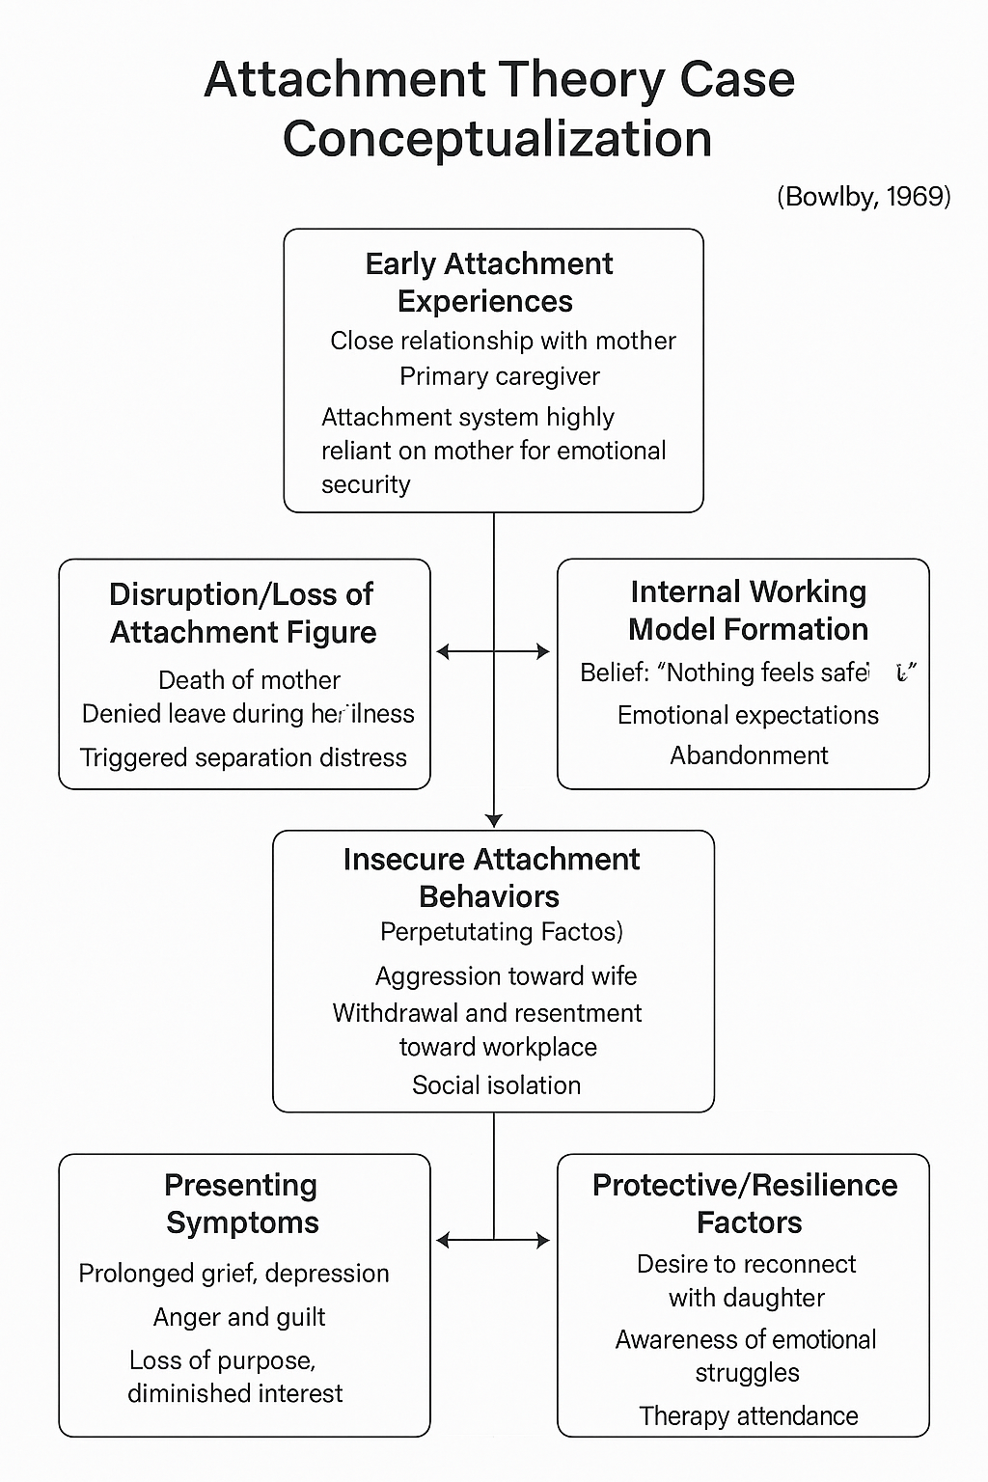

**Diagnosis**

Prolonged Grief Disorder (**F43.8)**

**Client Prognosis**

The client’s prognosis is **guarded**. Although he shows some understanding that his thinking patterns are unhelpful, his strong emotional reactions especially irritability and withdrawal indicate that he struggles to cope with distress and may resist deeper therapeutic work. His motivation to improve is inconsistent; while he sometimes expresses a desire for help, he often becomes disengaged or agitated during sessions and frequently asks to leave early. This back-and-forth attitude could slow down progress. However, with steady support, a strong therapeutic relationship, and interventions that focus on helping him manage emotions and stay engaged, gradual improvement is possible over time.

**Implementation of Theraputic Strategies**   
The following intervention plan was implemented to address the client’s emotional and behavioral concerns linked to Prolonged Grief Disorder.

* Building and Maintaining Rapport
* Psychoeducation on Grief and Emotional Responses
* Emotion Regulation Strategies
* Grief Narrative and Memory Work
* Cognitive Restructuring
* Motivational Interviewing
* Relaxation Techniques (Deep Breathing, PMR)
* Guided Imagery
* Behavioral Activation
* Relapse Prevention

**Building and Maintaining Rapport**  
Early sessions focused on creating a safe therapeutic environment, encouraging open communication while respecting the client's pace. Despite occasional withdrawal and irritability, the non-judgmental space allowed gradual trust-building, which laid the foundation for deeper intervention.

**Psychoeducation on Grief**  
The five stages of grief were discussed, and the client was encouraged to relate these stages to his personal experience. Information about how grief affects thought processes, mood, behavior, and physical symptoms (e.g., sleep and appetite disturbances) helped increase the client’s insight and reduced confusion around his emotional responses. Visual aids and relatable examples were used to enhance understanding.

**Emotion Regulation Strategies**  
The client was taught basic emotion regulation techniques to manage overwhelming emotions like anger, guilt, and despair. These included diaphragmatic breathing, grounding through sensory awareness, and body scanning. The therapist demonstrated these skills and practiced them in-session with the client, then encouraged use between sessions. These tools helped the client gradually shift from reacting impulsively to pausing and self-soothing in moments of distress.

**Grief Narrative and Memory Work**  
As rapport strengthened, the client was guided through narrative therapy exercises focused on recounting significant memories and the day of his mother's passing. He was supported in expressing unresolved emotions such as guilt and helplessness related to not being present at her death. Through letter-writing exercises and memory recall prompts, the client accessed deeply held feelings, which were processed in a safe, structured way. This allowed emotional release and helped integrate the loss into his personal story.

**Cognitive Restructuring**  
Cognitive distortions, such as “I failed my mother” or “I should have done more,” were explored using cognitive restructuring techniques. The therapist used Socratic questioning to examine the evidence for and against these beliefs. The client was encouraged to consider alternate perspectives and reframe his interpretations. Cost-benefit analysis was used in emotionally charged moments to help the client evaluate the consequences of impulsive behavior versus adaptive coping. Over time, the client began to recognize and challenge his negative thought patterns more independently.

**Motivational Interviewing**  
Due to the client’s fluctuating willingness to engage in therapy, motivational interviewing was employed to explore ambivalence. The therapist validated the client’s internal conflict and used reflective listening to identify his personal values, particularly his role as a father and provider. These discussions helped strengthen his internal motivation to remain in therapy and work through his grief. Motivation was revisited as needed throughout the sessions to sustain engagement.

**Relaxation Techniques**  
Relaxation methods were used to reduce physiological symptoms of stress, including headaches, sleep issues, and muscular tension. Deep breathing was practiced in session, with the client instructed to inhale slowly, hold, and exhale. Progressive Muscle Relaxation (PMR) was introduced to help release physical tension in a systematic manner. The client initially struggled to stay focused but reported a reduction in bodily tension and greater calm after repeated practice.

**Guided Imagery**  
The client was guided to visualize calming places associated with emotional safety, drawing from Guided Imagery techniques (Singer, 1974) to reduce anxiety and promote emotional regulation. The intervention aimed to create a mental space of comfort, emotional safety, and reflection. The client was encouraged to sit comfortably and close his eyes while the therapist guided him through a peaceful mental scenario, inviting him to visualize a calm, secure place that symbolized emotional relief. Suggestions included imagining the presence of his late mother in a serene setting and engaging with emotionally comforting elements associated with her memory (e.g., her voice, appearance, or presence during earlier peaceful moments).

The process lasted for about 10 minutes. The therapist maintained a calm, steady tone and encouraged the client to notice bodily sensations and emotional reactions during the imagery. The client initially appeared hesitant but gradually relaxed as the imagery progressed. Post-exercise, the client reported a sense of emotional release and stated that the imagery allowed him to momentarily reconnect with his mother’s memory without feeling overwhelmed. This experience helped regulate his affect and supported therapeutic engagement during the remainder of the session.

**Behavioral Activation**  
To address the client’s withdrawal, low energy, and loss of interest in activities, behavioral activation strategies were employed. The therapist collaborated with the client to identify previously enjoyable or meaningful tasks that had been abandoned since the loss. Simple, manageable goals were set, such as engaging in brief daily routines, re-establishing consistent sleep and wake times, and performing small acts of self-care. The client was encouraged to track these activities and reflect on any emotional changes. Over the course of therapy, the client demonstrated gradual improvement in daily functioning, including increased engagement in routine tasks and decreased emotional shutdown. Behavioral activation played a key role in reintroducing structure and restoring a sense of control.

**Relapse Prevention**

A relapse prevention plan was collaboratively developed with the client to maintain therapeutic gains and manage grief-related setbacks. High-risk triggers identified included anniversaries, family gatherings, workplace stress, and reminders of the deceased. The client was guided to recognize early warning signs such as emotional numbness, irritability, withdrawal, and disturbed sleep. Coping strategies reinforced during therapy such as deep breathing, grounding, progressive muscle relaxation, guided imagery, and cognitive restructuring were reviewed for continued use. The client was encouraged to maintain daily structure, engage in meaningful activities, and utilize supportive connections. An emergency coping plan was outlined, including use of soothing techniques and reaching out for professional or social support if needed. Monthly follow-up sessions and self-monitoring tools were recommended to help sustain progress and emotional regulation.

**Session Plan**

**Session 1: Intake and Rapport Building**

* Conducted clinical interview and mental status examination
* Established therapeutic boundaries and confidentiality
* Built rapport through empathy and reflective listening

**Session 2: Psycho education on Grief and Emotional Processing**

* Explained normal vs. prolonged grief
* Introduced the five stages of grief
* Used visuals and relatable examples to increase insight

**Session 3: Emotion Regulation – Part I**

* Introduced diaphragmatic breathing and grounding
* Identified emotional triggers and practiced in-session regulation skills

**Session 4: Emotion Regulation – Part II**

* Continued practicing emotion regulation skills
* Taught body scan and self-monitoring techniques
* Encouraged use of skills between sessions

**Session 5: Grief Narrative – Part I**

* Initiated narrative therapy techniques
* Supported client in sharing memory of mother and day of loss
* Introduced structured letter-writing activity

**Session 6: Grief Narrative – Part II**

* Continued memory exploration and processing of unresolved emotions
* Facilitated safe expression of guilt and helplessness

**Session 7: Cognitive Restructuring – Part I**

* Identified self-critical beliefs (e.g., “I failed her”)
* Used Socratic questioning to examine and challenge distortions

**Session 8: Cognitive Restructuring – Part II**

* Applied cost-benefit analysis to impulsive thoughts
* Encouraged reappraisal and generation of alternative thoughts

**Session 9: Motivational Interviewing**

* Addressed therapy ambivalence and resistance
* Explored values (e.g., role as father) to build commitment to recovery

**Session 10: Relaxation Techniques**

* Practiced deep breathing and Progressive Muscle Relaxation (PMR)
* Processed feedback on physical and emotional response to these exercises

**Session 11: Guided Imagery**

* Conducted guided visualization focused on emotionally secure imagery
* Encouraged reflection on calming memories with mother
* Supported client in processing post-exercise emotions

**Session 12: Behavioral Activation & Closure**

* Reviewed progress and increased engagement in routines
* Set ongoing behavioral goals
* Reflected on therapy process and prepared for discharge

**Short-Term Goals:**

* Build therapeutic alliance and establish emotional safety
* Provide psychoeducation about prolonged grief and normalize symptoms
* Introduce emotion regulation techniques to manage distress
* Facilitate expression of grief through narrative and memory work
* Identify and begin restructuring maladaptive thoughts and beliefs
* Enhance motivation to engage in therapy and reduce ambivalence
* Teach basic relaxation skills for physiological and emotional calming

**Long-Term Goals:**

* Reduce intensity and frequency of prolonged grief symptoms
* Foster emotional resolution regarding the loss of the client's mother
* Improve psychological flexibility and coping with distress
* Promote behavioral engagement and re-establish daily functioning
* Strengthen adaptive belief systems and reduce self-blame
* Support development of long-term self-regulation strategies
* Encourage autonomy and readiness for independent emotional management

**Limitations:**

* The time-limited nature of the plan may not be sufficient for individuals with severe or complex grief reactions.
* The absence of family or systemic interventions may limit the effectiveness in resolving relational issues contributing to distress.
* Removing relapse prevention may reduce continuity of care or preparedness for future stressors.
* Cultural or spiritual dimensions of grief were not explicitly addressed, which may impact relevance for some clients.
* Emotional intensity during grief narrative and imagery work may require more sessions for adequate pacing and containment.

**Recommendations:**

* Extend therapy beyond 12 sessions if unresolved grief and emotional reactivity persist.
* Consider involving family in sessions or parallel psycho education to address relational dynamics.
* Reintroduce relapse prevention planning as a final step or through follow-up support.
* Integrate culturally sensitive grief practices and explore client’s spiritual beliefs if relevant.
* Monitor emotional pacing closely and adjust session content according to the client's distress tolerance.

**Outcome**

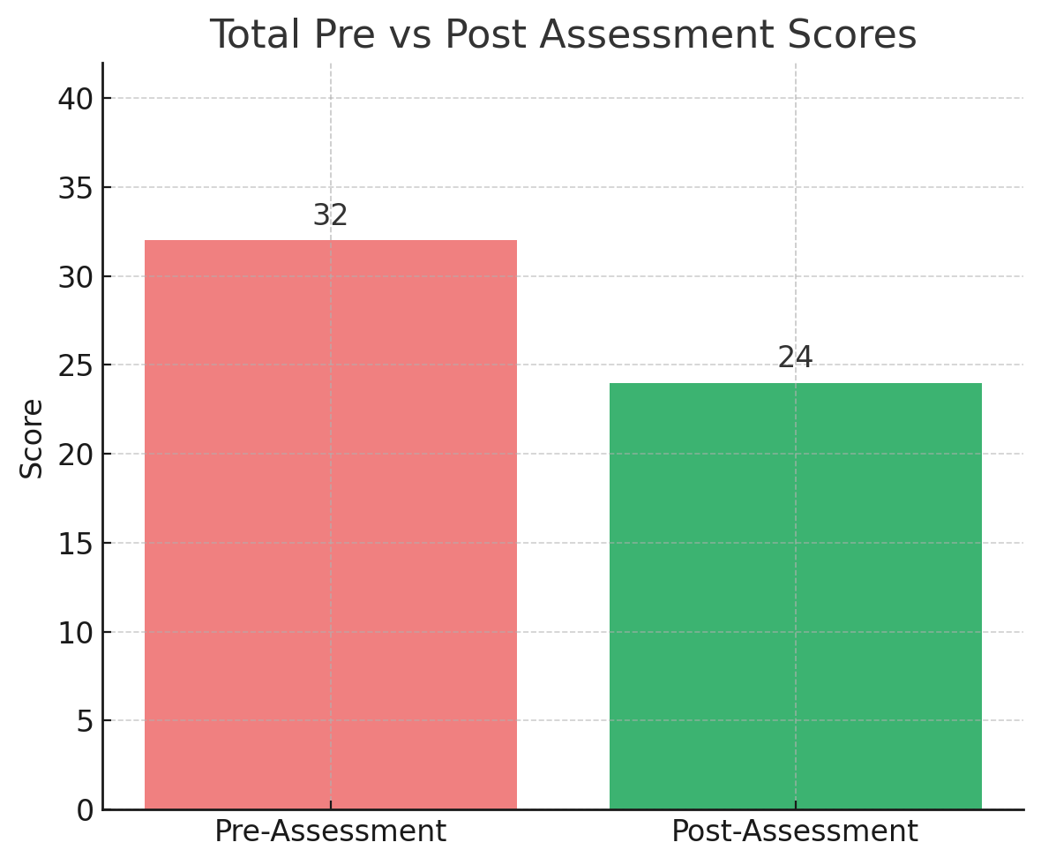

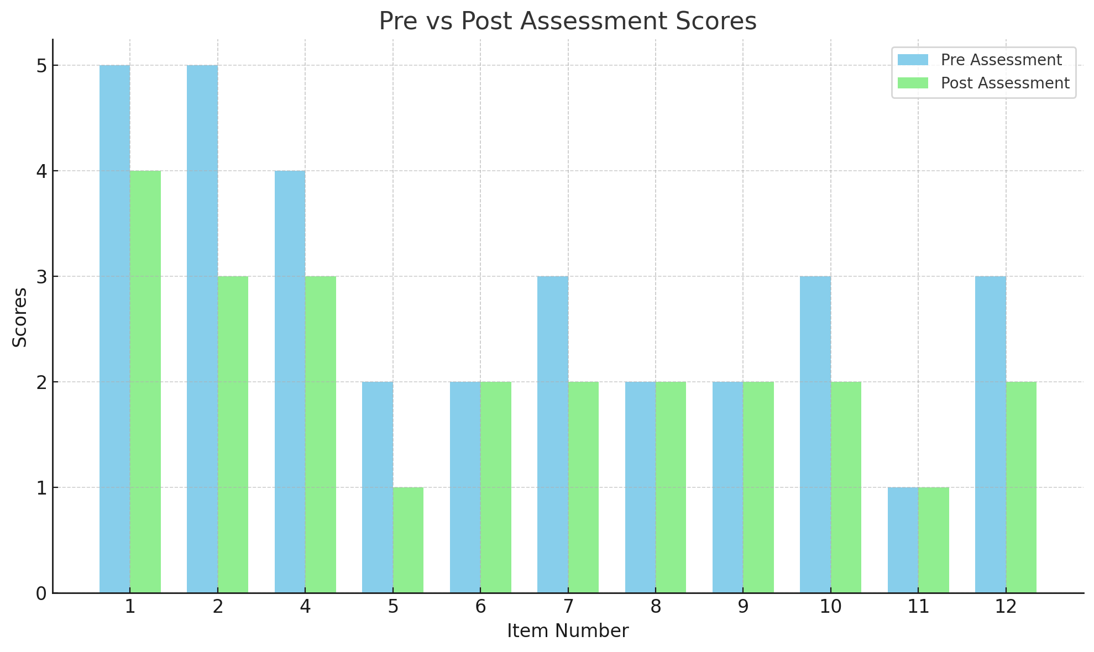

**Reference**

Beck, A. T. (1976). Cognitive therapy and the emotional disorders. International Universities Press.

Donker, T., Griffiths, K. M., Cuijpers, P., & Christensen, H. (2009). Psychoeducation for depression, anxiety and psychological distress: A meta-analysis. BMC Medicine, 7(1), 79. https://doi.org/10.1186/1741-7015-7-79

Jacobson, E. (1938). Progressive relaxation (2nd ed.). University of Chicago Press.

Linehan, M. M. (1993). Cognitive-behavioral treatment of borderline personality disorder. Guilford Press.

Martell, C. R., Dimidjian, S., & Herman-Dunn, R. (2001). Behavioral activation for depression: A clinician’s guide. Guilford Press.

Marlatt, G. A., & Gordon, J. R. (1985). Relapse prevention: Maintenance strategies in the treatment of addictive behaviors. Guilford Press.

Miller, W. R., & Rollnick, S. (2013). Motivational interviewing: Helping people change (3rd ed.). Guilford Press.

Neimeyer, R. A. (2001). Meaning reconstruction and the experience of loss. American Psychological Association.

Prigerson, H. G., Horowitz, M. J., Jacobs, S. C., Parkes, C. M., Aslan, M., Goodkin, K., Raphael, B., Marwit, S. J., Wortman, C., Neimeyer, R. A., Bonanno, G. A., Block, S. D., Kissane, D., Boelen, P. A., Maercker, A., Litz, B. T., Johnson, J. G., First, M. B., & Maciejewski, P. K. (2009). Prolonged grief disorder: Psychometric validation of criteria proposed for DSM-V and ICD-11. PLoS Medicine, 6(8).

Rogers, C. R. (1957). The necessary and sufficient conditions of therapeutic personality change. Journal of Consulting Psychology, 21(2), 95–103.

Singer, J. L. (1974). Imagery and daydream methods in psychotherapy and behavior modification. Academic Press.